CTM-I Use Case

Report Selection

Version 0.1

Use Case Name | Report Selection
Actor | Firm, Market Ops, Operations, App Support
Pre-conditions /Assumptions | User has Browser and is aware of the http path to the application.  User has successfully logged into the CTM-I application.  User has the right role to see the menu options.
Post Conditions | None
Screenshot | 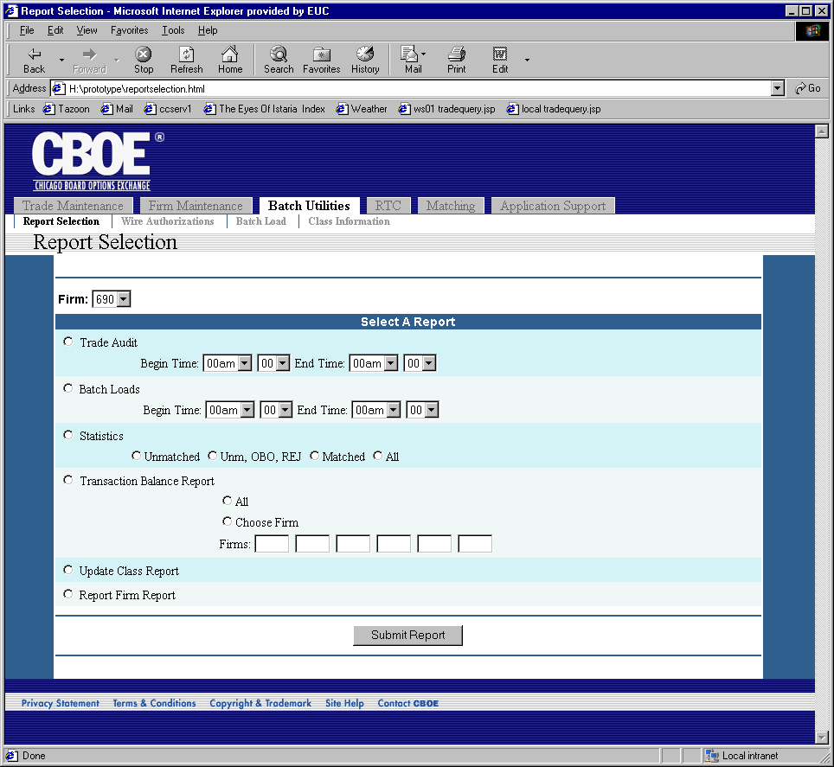
Flow of Events | - User will select “Report Selection” from the menu  - Report Selection screen will display  - The user will be allowed to select the type of report they want to submit.  - Trade Audit Report  - Batch Loads Report  - Statistics Report  - Transaction Rebalance Report  - Update Class Report  - Report Firm Report  - Firm is required on some reports. The firm will be defaulted based on the user logged in. If the user is associated with a firm, then that firm will be defaulted. The firm will not be validated on entry.  - Normal Users will be limited to the firms on their authorization list.  - Some reports require a firm. If no firm is entered, the user will be notified to enter a firm.  - If Statistics Report is chosen, the user must select and option for the report filter.  - Unmatched  - Unm, OBO, Rej  - Matched  - All  - Trade Audit Report and Batch Load report have parameters that can be selected if they are chosen.  - Begin Time  - End Time  - Begin Time and End Time will default to 0000am and 1159pm, respectively.  - Validation will occur to ensure the Begin Time is before the End Time.  - Transaction Rebalance Report is by firm. The user must select to have all firms on the report, or enter up to six firms to have on the report.  - The user can submit the report by clicking the “Submit Report” button.  - The report request is submitted to the appropriate service in CTM-R for processing.  - Upon successfully sending the report to CTM-R to process, a message will be displayed telling the user that the report has been submitted.
Alternative Path

